NO HARD COPY OF CALL UP LETTER WILL BE SENT

INDIAN ARMY BY EMAIL & SMS

Fax : 0755-2735980(Time 0830-1330hrs) Selection Centre Central
Tele : 0755-2702223 (Time 0830-1330hrs) Sultania Infantry Lines
IVRS : 0755-2731245/55 Bhopal (MP)-462001
Web : www.joinindianarmy.nic.in

SCC/7302/45/CU 03 Dec 2014

To

Candidate please ensure your roll no and name
as mentioned in Indian Army Web Site

SSB INTERVIEW NCC(SPL)-37 : APR 2015 COURSE IN THE ARMY

Dear candidate,

1. We are pleased to inform that you are nominated to attend SSB interview for joining the Officers Training Academy. Your Roll NO is mentioned against your name in Excel Sheet attached. Please quote Roll No in all future correspondence.
2. You are required to report at Parking Zone outside platform No 6, ‘BHOPAL RAILWAY JN’ on the date and time as given below. Our representative will receive you and arrange your conveyance to the Selection Centre. Documentaion and other preliminaries of testing will commence the same day :-

Ser No | Date of Reporting | Time of Reporting | Choice | Batch
(a) | 20 Jan 2015 | 1400 hours | One time Call Up | Regular

3. Under unavoidable / exceptional circumstances, reporting date given may be changed by this Centre based on availability of batches/dates. In this case you will be required to send an application (Specimen attaced) well in advance. The date will be considered changed only on receipt of confiramtion from this Centre. In this case you will also be required to bring a certificate obtained from the authority as indicated below, enumerating the circumstances under which you could not report on the given date.

- For Educational / Health Constraints

Ser No | Circumstances/ Constraints | Certificate to be Signed By
(i) | Educational | Principal/ Head of the Institute
(ii) | Health | Government Medical Officer

- For Social/ Administration Constraints

Place of your residence | Certificate to be Signed By
Place of your residence | Village | Town | City | Metropolitan
Place of your residence | Sarpanch/Gram Pradhan | ADM / SP | DM / SSP | Commissioner / IGP/ Mayor

4. Common Call Up instructions for SSB interviews are available on the above mentioned website. However, a copy of the same is enclosed herewith for your information and compliance. Candidates are required to bring the following :-

(a) Marks Sheets and Passing Certificates of 10th and 12th Standards.

(b) Semester/Year Wise independent marks sheets of Graduation with aggregate of min 50% marks.

- Degree / Provisional Degree Certificate of Graduation.

- NCC ‘C’ Certificate with minimum ‘B’ Grading.

- Your idedntity proof with photographs. (Anyone of college ID Card, Voter ID Card, PAN Card, Admit Card, Passport, Driving License etc).

- In case of final year students, bonafide certifciate from College / University be produced at the time of reporting (Specimen attachec).

(g) Items as mentioned in para 1 of Call up instructions.

5. You are also required to ensure the following:-

- In case of candidates appearing in their final semester/year exam, they are required to bring a Bonafide Certificate on the original letter head duly signed by Principal/Head of the institution stating that you are appearing in the final semester/year exam which must be completed before commencement of this course in the academy ie latest by 01 Apr 2015 and result of the same be declared within 12 weeks. (See specimen at Appendix ‘A’)

(b) In case, your original documents are deposited with some institution for pursuing higher studies, you are required to bring a bonafide cum custodian certificate duly signed by the Principal/head of institution and two photocopies each duly attested by the same authority. (See specimen at Appendix ‘C’)
2

(c) Candidates who have appeared for the SSB interview of SSC(NT)-101 course need not avail opportunity of appearing for NCC(Spl)-37 course as the vacancies for NCC(Spl) is part of SSC(NT). Candidate should bring a Certificate to this effect at the time of reporting (speciment as below) :-

DECLARATION CERTIFICATE

1. I______________________________________ (Name of Candidate), Roll No _______________ son of Shri ______________________________(Father’s Name) hereby declare and undertake that I have not availed / will not avail any SSB interview for the same course of SSC (NT)-101 Course as CDSE Candidate for OTA commencing in Apr 2015.

2. I fully understand that any willful misrepresentation of facts or concealment of information will result in cancellation of my candidature and I may also be debarred either permanently or of a specified period from applying for future courses.

Place : ____________ (Signature of the Candidate)
Name : ________________
Dated : Roll No : _______________
Batch No : _____________
Chest No :_____________

Note :- Receiving Call Up letter does not qualify the candidates. They are advised to ensure their eligibility criteria as per notification for NCC(Spl)-36 course before move for SSB interview.

Advisory :- In order to familiarize yourself with the SSB procedure being followed, you are advised to watch the movie “5 Days at SSB” by following links:-
http://www.joinindianarmy.nic.in officer SSB interview procedure & Movie SSB Schedule Movie 5 Days at SSB.

6. Our representative wearing an arm band (TOP HALF RED and BOTTOM HALF BLACK with the inscription 'SSB') will be present at Movement Control Office (MCO) located at Bhopal Railway Station, who will arrange your reception and conveyance to this Centre. In case of difficulty you may contact the Call Up Officer or the Duty Officer at the Telephone No given above.

7. Testing This will last for five days, in two stages excluding the day of arrival. The details are as under: -
- Stage I The Stage I testing shall commence at 06:30AM on the first day and will comprise the following :-
- An intelligence Test.
- A Picture Perception and Discussion Test. (PPDT)
- In case of your rejection in Stage I, you shall be returned from the Centre by 1 PM that day.
- Stage II The Stage II tests comprise the following for the next four days :-
- Psychological Tests.
- Group Test I and II for two days (in case of excess number of candidates, GTO Tests may be conducted in one day)
- Interview.
8. Free boarding and lodging will be provided to you for the period of your stay at the Selection Centre.
9. Call up instructions for your guidance and compliance are enclosed.
10. Please bring this letter with you and deposit the same at the Centre on arrival.
11. You are entitled to get travelling allowance in case you are coming to SSB for the first time for this entry.
12. Please note that no lunch will be provided by the Selection Centre on the day you report to the Selection Centre.
13. Medical Examination.
- You should be physically fit and free from ailment or any health problem which may hamper your performance in the physical tests/interview.
- In case, you qualify in the Stage-II testing, you shall be required to undergo a Special Medical Board (SMB) over the next four to six days. In exceptional and unavoidable circumstances, it may take upto eight days.
- In your own interest your are advised to undergo a preliminary medical chek-up for wax in ears, refractory error of eyes, fungal infections of skin, eosinophilia, knock knee and flat foot or any other disease before reporting for SSB interview.

Note: - In case you are found unfit in the SMB, you are eligible for Appeal Medical Board (AMB) within 42 days from the date of approval of the SMB. In case, you are found unfit even in the AMB, a final appeal i.e. Review Medical Board (RMB) application has to be submitted within 24 hours of approval of the AMB. Grant of RMB is at the discretion of the Medical Authorities.

14. Candidates will strictly adhere to laid down timings.

15. Candidate will not visit testing areas after testing hours.

16. The conduct of the candidates both in the Selection Centre as well as when visiting outside areas should be gentleman like.

17. Any contravention of above orders or any act of indiscipline will invite immediate cancellation of candidature on disciplinary grounds.

18. Cases of serious breach of discipline and conduct will be handed over to civil police and FIR registered accordingly.

19. Candidates are not permitted to use mobile phones during the conduct of tests.

Enclosures :-  (a) Joining Instructions  (b) Appendices ‘A’ to ‘E’ | sd/-  Call Up Officer  Selection Centre Central Bhopal (MP) - 462001 For Commandant
CALL UP INSTRUCTIONS FOR GUIDANCE AND COMPLIANCE OF CANDIDATES
ATTENDING SERVICE SELECTION BOARD INTERVIEW
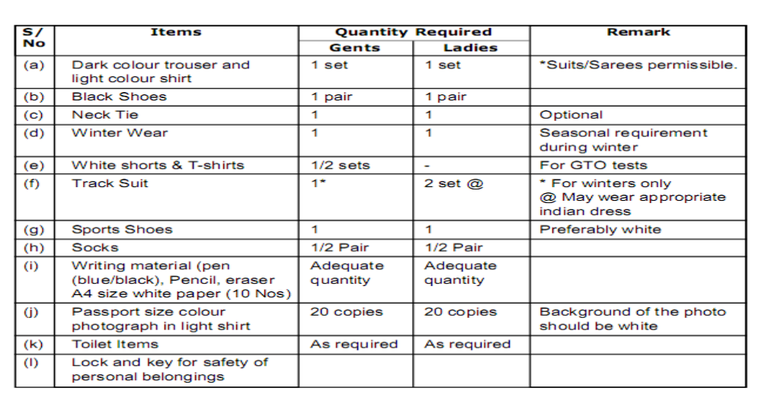1. Items to be Brought. The following items will be required for the interview :-

Cash and Valuables. A maximum of Rupees One Thousand over and above what is required for travelling expense may be carried. No valuables should be carried. Safe custody of cash and valuables will be the responsibility of the candidate.
- Documents. Please bring the following documents in ORIGINAL at the time of reporting at this centre along with two photocopies each duly attested by a Gazetted Officer and adhere to the instructions with regard to the documents as given below :-
- Matriculation/Higher Secondary or equivalent pass certificate for verification of your date of birth. (No other document except Matriculation/Higher Secondary or equivalent pass certificate is acceptable for age proof.)
- Intermediate/10+2 pass certificate.
- Marks Sheet of Matriculation / Higher Secondary or equivalent.
- Marks Sheet of Intermediate/10+2 examinations.
- Semester/Year wise independent marks sheets of Graduation/Post Graduation.
(For Graduation/Post Graduation entries.)
- Degree/Provisional Degree Certificate. (For Graduation/Post Graduation entries.)
- NCC ‘C’ Certificate. (For NCC/NCCW entries.)
- Certificate of Registration with the Bar Council of India/State. (For JAG entries.)
- UPSC admit card. (For UPSC entries.)
- Identity Proof with photograph (any one of School/College ID Card), PAN Card, Voter ID Card, Passport, Driving Licence etc. (In case of candidates of NDA/10+2 (TES) entries, a certificate with photograph issued by Principal as proof of identity.)
- Risk Certificate duly signed by parent/guardian. (For NDA and 10+2 TES entries)
- Hard copy of the application with photograph if you had applied ONLINE.

Attention :- In case, you fail to produce any requisite document in ORIGINAL, as mentioned above at the time of reporting, you are liable to be returned without being interviewed and NO reimbursement of TA will be made.
Instructions for Lady Candidates In case a lady candidate is married (except who are issueless divorcee / issueless widow / widow of defence personnel), she is not eligible, and need not report for SSB interview. The call up letter may be treated as cancelled.
Important Note :-
- In case the result of final year/semester exam is awaited, the candidate will be required to submit a bonafide certificate obtained from the head of the institution on his original letter head, stating the current status of the candidate; date of completion of final year exam and declaration of result. (See specimen at Appendix ‘A’)
- For final year students only - If you are studying in final year of degree course, you are required to bring a certificate obtained from the head of the institute / College/ University stating that you are studying in final year of degree course and going to appear in the final examination during and result will be declared by (month & year) (See specimen at Appendix ‘B’)
- Candidates who have submitted their Certificates and Marksheets in College/ University for Pursuing Higher Studies. Please bring a bonafide custodian certificate along with certified true copies of those documents. (See specimen at Appendix ‘C’)
- Risk Certificate Applicable to NDA / TES / 10+2 (Tech) Candidates. You will bring Risk Certificate as per specimen attached.
- No Claim Certificate - Required to be submitted by the candidates for Graduation/ Post Graduation entries. (See specimen attached)
For Attention of Candidates :-

- You are required to bring original NCC ‘C’ Certificate (Army / Navy / Air Force Wing) with one attested copy, if competing against reserved vacancies for NCC ‘C’ Certificate holders.
- Bring certified true copy duly authenticated/signed by the competent authority of every achievement you have obtained in the field of NCC, Games, sports and other extra curricular activities.
- Candidates declared successful in the SSB interview are required to submit at the earliest a photocopy duly attested by Class-I Gazetted Officer of all such provisional degree / degree certificate, acquired after the SSB interview to the following :-
FOR ARMY ENTRIES - Additional Director General of Recruiting, Integrated Headquarters Ministry of Defence (Army) West Block - III, R K Puram, New Delhi - 110066.
FOR NAVAL ENTRIES - Directorate of Manpower Planning and Recruitment (DMPR), Recruiting Card Library (Navy) IHQ of MOD (Navy), ‘C’ Wing, Sena Bhawan, New Delhi - 110011.
- Candidates are further advised that documents already verified at Selection Centre need not be submitted again to IHQ MoD (Army/Navy). In case of loss of such documents, the onus will entirely rest upon the candidate.
- Travelling Allowance (TA).
Candidates appearing for SSB interview for the first time for a particular type of commission ie permanent or short service, shall be entitled for AC-III tier to and fro railway fare or bus fare including reservation cum sleeper charges within the Indian limits. Candidates applying for the same type of commission will not be entitled to travelling allowance on any subsequent occasion.
Caution | You are liable to forfeit travelling allowance if you fail to :-  Meet the eligibility criteria and educational qualifications as required. Produce the original documents as given in the instructions. Produce ID proof as mentioned in the instructions.

- Change of Address - Change of address, if any, after submission of application will be intimated to Additional Directorate General of Recruiting (Rtg-6), Adjutant General’s Branch, IHQ of MoD Army Headqaurters, West Block - III, R.K. Puram, New Delhi-900108, C/o 56 APO (for Army Entries) and Directorate of Manpower Planning and Recruitment (DMPR), Recruiting Card Library
(Navy) IHQ of MOD (Navy), ‘C’ Wing, Sena Bhawan, New Delhi - 110011. (for Naval Entries) and this centre. (See specimen at Appendix ‘E’)

- Warning. A candidate should withhold his move if he is a resident of Bhopal, his permanent address is Bhopal or has a guardian/relative/friend serving in this Selection Centre or his unit is located in BhopaI (For serving candidates only), intimate this centre immediately the particulars of the person concerned and await further instructions. Any attempts made by candidate, his relatives or friends to influence the members of Services Selection Board in his favour either verbally or in writing will result in his name being removed from the list of candidates. In all matters of discipline, the Centre Commandant will be the final authority and no appeal against his decision will be entertained.

- Compensation. Government is not responsible for any compensation to the candidates or to their guardians/heirs for injuries sustained by them during the period of testing. However, facilities exist to attend to the candidates falling sick or sustaining injuries during their stay at the Centre.

- Correspondence. In all correspondence, please quote this letter No and date, UPSC
Roll No, Name of the Entry, registration number and full postal address. Email + Contact Number.

- Service personnel only. In case you are already serving in the Army/Navy/Air Force, this letter will be put up to your Officer Commanding and your move in connection with this interview will be treated as temporary duty under the provisions of TR-1 92 (f) (ii). As such, you will bring a retum journey railway warrant for your journey. You are required to bring one set o f uniform.

9. For Information of Officer Commanding Unit.
- In case, the candidate has been posted out of your Unit, please, forward this letter to his present unit immediately, under intimation to this Centre.

- Copies of movement order and DO Part II will not be endorsed to this Centre Separate movement order will be issued to every individual required to report to thi s Centre.
- In case, the individual cannot present himself for interview, this Centre should be informed immediately.

- No Arms and Ammunition will be carried by the candidate.

- Candidates will be in possession of free return railway warrant, Identity Card and Health Record Card.

- Candidates is required to bring a set of uniform.

- Apprise this Selection Centre immediately in case your unit is deployed in Bhopal.

10. Physical Conditioning - Candidates who qualify the SSB interview and medical examination are advised to follow the under mentioned regimen daily in order to keep themselves in good physical condition at the time of reporting at the Academy :-
(a) Running 2.4 Kms in 15 Minutes Sit ups-25
(b) Push ups-13
(c) Chin ups (minimum 06)
(d) Rope Climbing (3 to 4 Meters)
Candidates reporting for their SSB should take care of the following medical points failing which he/she is liable for rejection :-

- Ideal Age, Height and Weight (Male) :- It should be within permissible limits (+ or -10%) of the ideal weight given in the table. In recording fraction lower than 0.5 Kg will be noted and 0.5Kg, above will be recorded as 1 Kg. A correlation table between age, height and average weight is given below for guidance of candidates :-

In case of candidates belonging to the North East and hilly areas like Gorkhas, Nepalese, Assamese and Garhwalis, the height will be relaxed by 5 cms and weight commensurate with reduced heights.
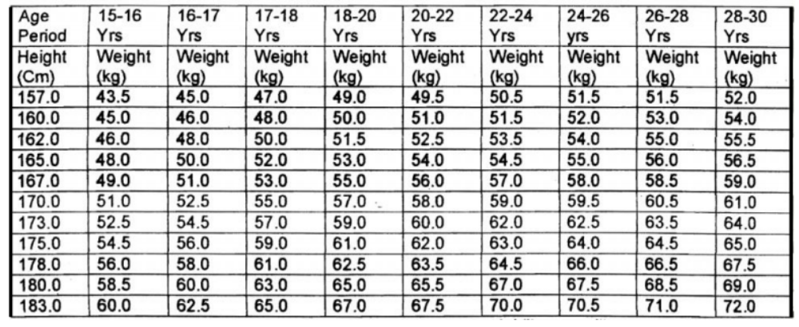(b) Ideal Age, Height and Weight (Female) :-
Age Period | 20 to 24 Yrs | 25 to 29 Yrs | 30 Yrs
Height (Cm) | Weight (Kg) | Weight (Kg) | Weight (kg)
148.0 | 39.0 | 41.0 | 43.0
150.0 | 40.0 | 42.0 | 43.0
153.0 | 42.0 | 43.0 | 45.0
155.0 | 43.0 | 44.0 | 46.0
158.0 | 45.0 | 45.0 | 48.0
160.0 | 46.0 | 46.0 | 49.0
163.0 | 47.0 | 47.0 | 51.0
165.0 | 49.0 | 49.0 | 53.0
168.0 | 50.0 | 50.0 | 54.0

The minimum acceptable height and weight for woman candidate is 152 cm and 42 kg. In case of candidates belonging to the North East and hilly areas like Gorkhas, Nepalese, Assamese and Garhwalis, the height will be relaxed by 5 cms and weight commensurate with reduced heights.

- No wax in the ear.
- No skin disease i.e. Acne vulgaris, warts, fungal infection.
- No dental cavaties including temporary filling and minimum 14 dental points.
- No vision defect i.e. vision corrected by glasses.
- No hernia/abdominal operation in past one year.
- No hydrocele/ varicocele.

NO CLAIM CERTIFICATE
(For Graduation/Post Graduation Entries)
I father / guardian of
who is a candiate for NDA /
IMA / OTA / Naval Academy / entry in the Army / Navy, hereby certify that I fully understand that my son/ daughter/ ward will, if required, attend the Services Selection Board Interview with my full and free consent and at my own risk and that I or my son/ daughter/ ward shall not be entitled to claim any compensation or other relief from the government in respect of any injury or disability which my son/ daughter/ ward may sustain in the course of or as the result of any of the tests given to him at the SSB interview, whether due to his own negligence or the negligence of any other person or otherwise.
Place :  Date : | Signature of Parent / Guardian  Address ........................................................................ ........................................................................ ........................................................................

RISK CERTIFICATE

(For NDA/10+2 (TES) /10+2 (Tech) Entries)

I ______________(Name) father/guardian of ________________(Name of candidate) who is a candidate for NDA / 10+2 (TES) / 10+2 (Tech) / Regular Commission in the Army / Navy, hereby certify that I fully understand that my son/ward will, if required, attend Service Selection Board Interview with my full and free consent and at my own risk and that I or my son/ward shall not be entitled to claim any compensation or retest for the same course or any other relief from the Government if son/ward sustains any injury during the course of /as result of any of the tests administered to him at the said Services Selection Board or while using military transport due to any reasons.
Signature of Parent / Guardian
Address …………………………………..
Place : .......................
Date : .........................
Appendix “A”

CANDIDATES WHO ARE STUDYING IN FINAL YEAR OF THEIR ACADEMIC SESSION/APPEARED FOR FINAL EXAMINATION/RESULT NOT DECLARED
(This certificate is required on the original letter head)
Certified that Mr __________________ s/o shri ______________________is a bonafide student of______________________________ (name of school/ college) and is presently studying in ____________ His final board / semester examination will be / was conducted during _______(month and year of exam) and the results are expected to be declared by ______________(month and year).
Place : (Signature of Principal/Registrar of the
Date : College/University where studying with stamp)
College/University round stamp

Appendix ‘B’
CERTIFICATE FOR PRE FINAL / FINAL YEAR STUDENTS OF
UNIVERSITY ENTRY SCHEME (UES) (PRE FINAL / FINAL YEAR) DEGREE COURSE ONLY
(This certificate is required on the original letter head)
It is certified that Mr _____is in Pre-Final / Final Year of degree course
and is going to appear in Final Year / Semester Examination during and Final
Year exam results will be declared by ________________(month and year). Mark sheets of all the semesters (up to IV semester for Pre Final year candidates / up to VI semester for final year candidates) along with two photocopies each duly attested are also enclosed herewith.

Place :
Date :
College/University round stamp (Signature of Principal/Registrar of the
College/University where studying with stamp)
Appendix “C”

CERTIFICATE FOR CANDIDATES WHO HAVE SUBMITTED THEIR CERTIFICATES
AND MARKSHEETS IN COLLEGE /UNIVERSITY FOR PURSUING HIGHERSTUDIES
(This certificate is required on the original letter head)

1. Certified that Mr______________________s/o Shri _______________________ is a bonafide student of _______________________(name of college/university) and presently studying in _______________________ (name of course to be mentioned). The following certificates and mark sheets in respect of the above individual have been deposited with this College/University/Institution in original for verification purpose :-

- It is further certified that photostat copies of the above documents have been verified by the undersigned and attested.

Place : (Signature of Principal/Registrar of the
Date : College/University where studying with stamp)
College/University round stamp

APPENDIX ‘D’

From
Roll No
Name
Father’s Name
Postal Address

Email
Mob No. ___________________________________
To
The Call Up Officer
Selection Centre Central Sultania Infantry Lines Bhopal - 462001
APPLICATION FOR CHANGE OF ADDRESS
Sir,
- Please refer to your Call Up letter bearing No SCC/730_/ /CU dated__________ .
- As per your Call Up letter quoted above, I am required to report to your Centre on for SSB interview of ____________ on _____________. But I am unable to report for SSB interview on the date as quoted above, due to the following reasons :-

Postal Address (as given in the application) |  |  | New Postal Address (To be changed in the application)

- May I request you to please include my postal address in the application for correspondence
- Thanking You. Yours faithfully

Date : ___________________ (Signature of candidate)
Appendix ‘E’
SPECIMEN APPLICATIONFOR CHANGE OF DATE OF SSB

From

Roll No
Name
Father’s Name
Postal Address
Email
Mob No.
To
The Call Up Officer
Selection Centre Central Sultania Infantry Lines Bhopal - 462001
APPLICATION FOR CHANGE OF DATE OF SSB INTERVIEW
Sir,
1. Please refer to your Call Up letter bearing No SCC/730_/ /CU dated__________
2. As per your Call Up letter quoted above, I am required to report to your Centre on for SSB interview of ____________ on _____________. But I am unable to report for SSB interview on the date as quoted above, due to the following reasons: -

- The following Certificates / Documents are enclosed herewith in support of the above reasons :-
(a)
(b)

4. May I request you to postpone my date of SSB interview to the absentees batch.

5. Thanking You.
Yours faithfully

